 |  | 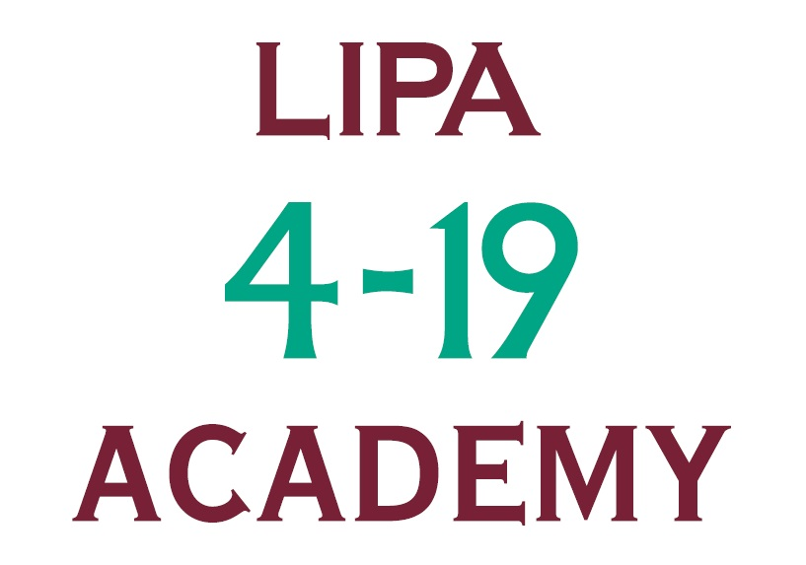
APPLICATION FORM – LIPA 4:19 Teaching Staff

CONFIDENTIAL

This information can be made available in other formats – please let us know about any specific needs you have

Application for appointment as:

Application Reference Number (to be completed by Personnel):

PERSONAL DETAILS

Surname: | First name(s):
Home Address: | Title: (Mr/Mrs/Ms/Miss/other)
 | Daytime Tel No:
 | Mobile No:
 | Email address:
Postcode: | Do you need a work permit? |  | *YES/NO  Please delete as appropriate

To the best of my knowledge and belief the information supplied by myself is correct
Signed ........................................................ Date ....................................

Note: To ensure, as far as possible, that the staff recruitment process is fair and equitable, this front
sheet is detached from the rest of the application form before it is passed to the shortlisting panel

Our Privacy Notice for Job Applicants is supplied overleaf

Privacy Notice for Job Applicants
As part of our staff recruitment process, we collect, process and store personal information about you.

Why do we collect your personal information?
In order to manage your application, we need to process certain personal information about you.
We only process your information as necessary for the purposes of progressing your application or as required by law or regulatory requirements.

Your provision of personal information is voluntary and you determine the extent of information you provide to us. However, please note that if you decide not to provide information, it may affect our ability to consider you for employment.

What personal information might we process?
During the recruitment process we capture some sensitive personal data about you (e.g. disability information). We do this in order to make reasonable adjustments to ensure as many people as possible can apply for jobs with us and to ensure that we comply with regulatory obligations placed on us with regard to our recruitment process.

Who do we share your personal information with?
Your personal information will be seen only by specific staff in the Personnel Department, the shortlisting panel (anonymised) and the interview panel.
Some of your information may be shared externally if it is necessary or required (for example in order to carry out psychometric testing).

How do we protect your information?
Our HR and Recruitment systems are protected to ensure that unauthorised or unlawful processing of personal information, accidental loss or destruction of, or damage to, personal information does not occur. This is done in accordance with our ICT Security Policy.
Your personal information will be retained for no longer than six months before being destroyed. We keep this information for this period to enable us to respond to any complaints (e.g. bias, discrimination) which may arise after the recruitment process has been completed.

Your Rights
You are entitled to see the information we hold about you.

Criminal records checks
Given the nature of our business, we have legal and regulatory obligations to ensure that, for a number of positions, the people we employ do not have a criminal record.

We therefore ask questions about any prior civil or criminal proceedings you may have been subject to and may also conduct criminal record checks.

These checks are only performed on candidates who have been selected for a role. Your consent will be requested before screening checks are performed.

Processing Conditions
Our entitlement to process your personal information is governed by a number of processing conditions. This means that we may rely on more than one of these conditions in order to process elements of your personal information throughout the recruitment process:

- We will process your personal information in the administration of your application;
- We will also process your personal information where it is required by law or regulation.

You are responsible for the information you provide or make available to us, and you must ensure it is honest, truthful, accurate and not misleading in any way.

Our full Privacy Notice for job applicants is posted on the Working Here page of our website.
If you have any queries about this notice or your personal information generally, including questions about accessing your personal information or correcting it, you should contact our Personnel Department in the first instance (personnel@lipa.ac.uk).

EQUALITY AND DIVERSITY MONITORING FORM

LIPA is an equal opportunities employer. The aim of our policy is to ensure that no job applicant or employee receives less favourable treatment on the grounds of sex, sexual orientation, marital status, race, religion, colour, nationality, ethnic or national origins or disability or is disadvantaged by conditions or requirements which cannot be shown to be justifiable.

Recruitment, selection and promotion procedures will be monitored to ensure that individuals are selected, promoted and treated on the basis of their relevant merits and abilities.

To assist us in monitoring the operation of its equal opportunities policy, and for no other reason, please answer the following questions by ticking boxes as appropriate. This information will be detached before your application is passed on for shortlisting.

Name:
Post applied for:

Date:

Ethnicity
What is your ethnic group? Please choose one section, then tick the appropriate box to indicate your cultural background:

Asian or Asian British |  | Mixed
Bangladeshi |  | White and Asian
Indian |  | White and Black African
Pakistani |  | White and Black Caribbean
Any other Asian background |  | Any other Mixed background
Black or Black British |  | White
African |  | British
Caribbean |  | Irish
Any other Black background |  | Any other White background
Chinese or other ethnic group |  | If you have ticked ‘Any Other’ – please describe you ethnicity here:
Chinese
Any Other
Nationality
Which one of the following statements about disability is most appropriate to you?
Nationality
National identity (if different)

eg British/Welsh

I am disabled |  | I am not disabled
Disability

Gender
Female |  | Male |  | Other*

* eg. Transitioning

Age

Date of birth

Where did you see this vacancy advertised? (please tick whichever box applies)
LIPA Website |  | The Echo |  | The Stage
Other Website |  | jobs.ac.uk |  | Jobcentre+
Word of Mouth |  | Other (please specify):

CRIMINAL CONVICTIONS
Certain posts are exempt from the Rehabilitation of Offenders Act 1974. Applicants for such posts are required to declare all criminal convictions, spent or unspent. This includes any posts where the post-holder is likely to have access to children or where there is potential for fraud. Where posts fall under this exemption, this will be indicated in the further particulars. Applicants for such posts must provide the following information:
Have you any criminal convictions (spent or unspent)? Yes/No

If yes, please provide details:

Are you included in any list of people barred from working with Yes/No
Children by the Disclosure and Barring Service?

Are you subject to a Prohibition Order or Interim Prohibition Yes/No
Order for teachers?

Failure to disclose convictions, cautions or bind overs which have not been filtered could result in withdrawal of any conditional offer, disciplinary action or dismissal. It is a criminal offence to apply or accept a position (paid or unpaid) working with children if you are excluded from such work by virtue of a court order or exclusion by the DBS.

Thank you for your assistance in completing this form

Application Reference Number (to be completed by Personnel):

EMPLOYMENT DETAILS Please give details of your present or most recent employment
Employer’s name: | Job Title:
 | Date Appointed:
 | Notice Required or date employment ceased:
Employer’s address: | Reason for leaving (if no longer with this employer):
 | Hours per week:
 | Basic Salary:
Bonuses/Allowances:
(Guaranteed)
Bonuses/Allowances:
(Not Guaranteed)
Brief outline of duties and responsibilities:

EMPLOYMENT HISTORY Most recent employment first. Give Month/Year for dates

Employers name and address: | Job title and an outline of duties: | From: | To: | Reason for leaving:

EMPLOYMENT HISTORY (Continued) Most recent employment first. Give Month/Year for dates
Employers name and address: | Job title and an outline of duties: | From: | To: | Reason for leaving:

EDUCATION AND TRAINING Give Month/Year for dates
Please note: we ask all successful candidates to provide original certificates evidencing qualifications claimed in this section. Please do not list qualifications here if you think you would have difficulty providing evidence for them as failure to provide them would lead to the withdrawal of any job offer.
School, College or University attended: | From: | To: | Qualifications / Results achieved:

Membership of Professional Bodies: | Year of Admission: | Admission by Exam? | Details of course:

Any other courses attended: | Date:

Please indicate availability for teaching
 | Monday | Tuesday | Wednesday | Thursday | Friday | Saturday | Sunday
Morning
Afternoon
Evening

REFERENCES
Please give names, addresses, work telephone numbers and occupations of two people who can be contacted for information relating to your work, one of which should be your current or most recent employer. References must cover your last two years’ work history.

May we approach your referees without further permission from you? YES/NO
First Referee | Second Referee
Name and title: | Name and title:
Job title (if appropriate): | Job title (if appropriate):
Address: | Address:
Email:
Relationship to you (e.g. employer, teacher etc): | Relationship to you (e.g. employer, teacher etc):

INFORMATION IN SUPPORT OF YOUR APPLICATION
Please include any further information which you believe is relevant to your application. Continue on a separate sheet if necessary

Do you hold a current and full driving licence? | YES/NO
Are you related to any senior member of the Institute staff or LIPA Council Director? | YES/NO

CRIMINAL CONVICTIONS
Certain posts are exempt from the Rehabilitation of Offenders Act 1974. Applicants for such posts are required to declare all criminal convictions, spent or unspent. This includes any posts where the post-holder is likely to have access to children or where there is potential for fraud. Where posts fall under this exemption, this will be indicated in the further particulars. Applicants for such posts must provide the following information:
Have you any criminal convictions (spent or unspent)? Yes/No

If yes, please provide details:

To be returned to:

Personnel Recruitment
The Liverpool Institute for Performing Arts

Mount Street

Liverpool
L1 9HF

Or email to recruit@lipa.ac.uk

by the closing date specified in the further particulars for this post.

LIPA - a registered charity No. 1001565 aiming to be an equal opportunity employer providing education and training in the Arts and Entertainment Industry.

